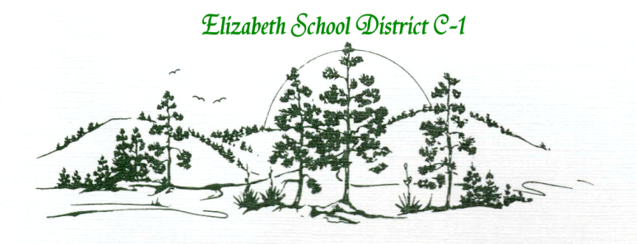

**CONNECT WITH ELIZABETH**

634 S. Elbert Street, PO Box 610

Elizabeth, CO 80107

303-646-1836

**Facebook:** facebook.com/Elizabeth.schools.9

**Twitter:** twitter.com/ESDK12

**Website:** elizabeth.k12.co.us

**News online:** smalltownbignews.com

**BOE Blog:** elizabethschoolsboe.blogspot.com



**ELIZABETH SCHOOL DISTRICT C-1 BOARD OF DIRECTORS’ MEETING**

**Meeting Notice**: The Elizabeth Board of Education gives public notice that the board is using an online forum to discuss matters related to the governance and operations of the school district.  The forum is considered to be an ongoing meeting and is subject to the provisions of the Colorado Open Meetings Act.  No formal action will be taken in the forum.  The public may view the discussion via the following website: <http://elizabethschoolsboe.blogspot.com>

**DISTRICT MISSION**

We believe that students are at the heart of everything we do.

**BOARD’S PURPOSE**

We will strive as a unified team of elected citizen volunteers to keep students at the heart of our decisions, to grow the district in a positive direction, and to focus on student success at every level.

**ESSENTIAL BOARD ROLES**

-Guiding the district through the superintendent

-Engaging stakeholders

-Ensuring alignment of policy, resources, and structure

-Measuring and celebrating achievement

-Modeling excellence

|  |  |  |
| --- | --- | --- |
| **Monday, August 11, 2014**  **Business Meeting**  **Board Room**  **7:00 pm – 9:00 pm**  **Agenda** | | |
|  | **Informal Gathering**  **Meet New Directors and Principals** | 6:30pm |
| 1.0  2.0  3.0 | **Call to Order**  **Roll Call**  **Pledge of Allegiance** | 7:00-7:05  (5 min) |
| 4.0 | **Education Showcase/Recognitions** | 7:05-7:15  (10 min) |
| 5.0 | **Approval of Agenda/Additions/Deletions/ Blanket Motion** | 7:15-7:20  (5 min) |
| 6.0  6.1  6.2  **BOARD’S CORE VALUES**  -Students first  -Respect  -Teamwork  -Learning  -Continuous improvement  -Fiscal sustainability  **BOARD’S FOCUS AREAS**  -Increasing student achievement  -Investing in excellence for all students  -Enhancing sustainable employee salaries and benefits  -Building a long-term planning culture and system  **BOARD’S STRATEGIC LISTENING LINKS**  -Committees and Associations  -Conferences and Conventions  -Constituent Surveys  -BOE Meet and Greet  -BOE School Ambassador Program | **Approval of Minutes**  Minutes from BOE Meeting 6/9/14  Minutes from Special BOE Meeting 7/28/14 | 7:20-7:25  (5 min) |
| 7.0  7.1  7.2  7.3  7.4  7.5 | **Communications**  Chief Financial Officer (10 min)  -Budgeted Disbursements Exceeding $5000  -Financial Statements  HR Update (10 min)  Technology Update (10)  Superintendent Report (10 minutes)  Board of Education (10 minutes) | 7:25-8:15  (50 min) |
| 7.5 | **Public Participation** | 8:15-8:25  (10 min) |
| 8.0  8.1  8.2  8.3  8.4 | **Consent Agenda**  Transfers/Changes  Terminations/Resignations/Non-Renewals  New Hires  Agreement with Children’s Hospital for Athletic Training Services | 8:25-8:30  (5 min) |
| 9.0 | **Action Items** | 8:30-8:35 |
| 10.0  10.1  10.2  10.3 | **Discussion Items**  Ambassador Program  ESD101  Consideration of Bond/Mill Levy | 8:35-9:05  (30 min) |
| 11.0 | **BOE Planning**  Next Board Meeting 8/25/14 | 9:05 – 9:15  (10 min) |
| 12.0 | **Executive Session** if needed under C.R.S. 24-6-402 (4) ( ) |  |
| 13.0 | **Adjournment** | 9:00 pm |

During the BOE Business Session, time will be provided on the agenda during public participation, for any resident of the district to address the BOE. Public participation is an opportunity to present brief comments or pose questions to the board for consideration or follow up. Each person is asked to focus their remarks to three minutes. The boundaries are designed to help keep the meeting focused and in no way should limit conversations beyond the board meeting.

Times indicated on this agenda are estimates, actual times may vary.